 ООО "Саратовский завод конвейеров "Феникс" Заказчик: Организация **___________________**  
 +7 (8452) 98-75-17, 98-75-15, 8-917-208-75-15 Телефон  **__________________**  
 E-mail: [zpo-feniks@yandex.ru](mailto:zpo-feniks@yandex.ru) E-mail  **__________________**  
 Наш сайт: <http://конвейер-транспортер.рф>

**Опросный лист для заказа амортизирующих роликов ВИД 1**

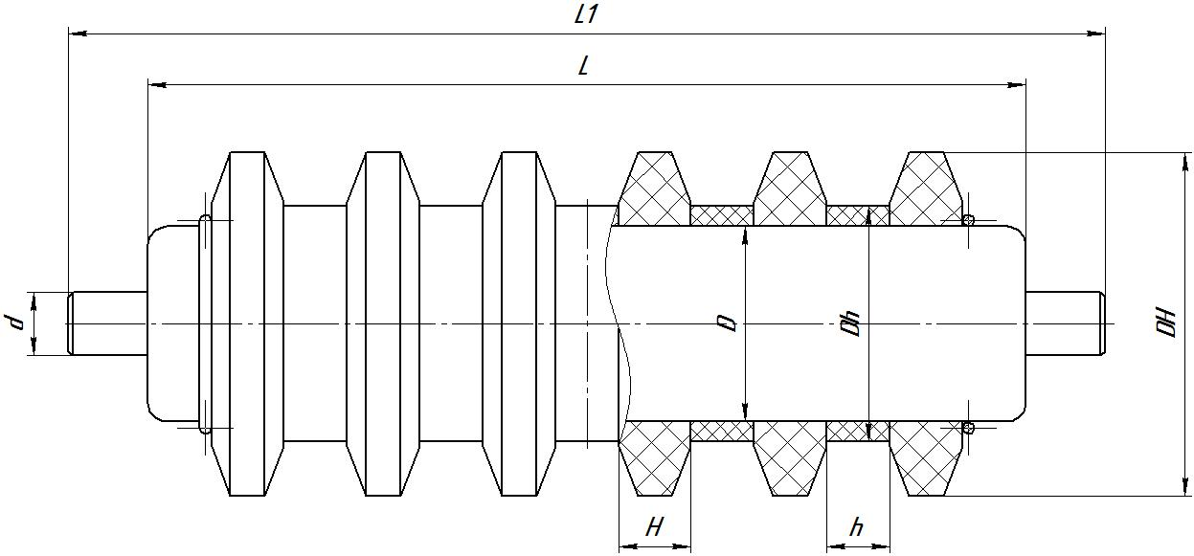

|  |  |  |  |  |  |  |  |  |  |  |  |  |  |  |  |
| --- | --- | --- | --- | --- | --- | --- | --- | --- | --- | --- | --- | --- | --- | --- | --- |
| **№** | **L** | **L1** | **D** | **d** | **d1** | **l** | **l1** | **l2** | **b** | **DH** | **Dh** | **H** | **h** | **Подшипник** | **Кол-во** |
|  |  |  |  |  |  |  |  |  |  |  |  |  |  |  |  |
|  |  |  |  |  |  |  |  |  |  |  |  |  |  |  |  |

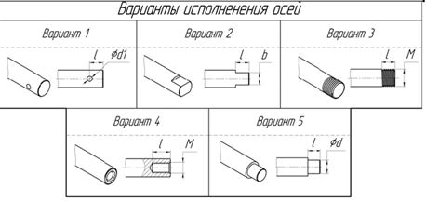

**Опросный лист для заказа амортизирующих роликов ВИД 2**

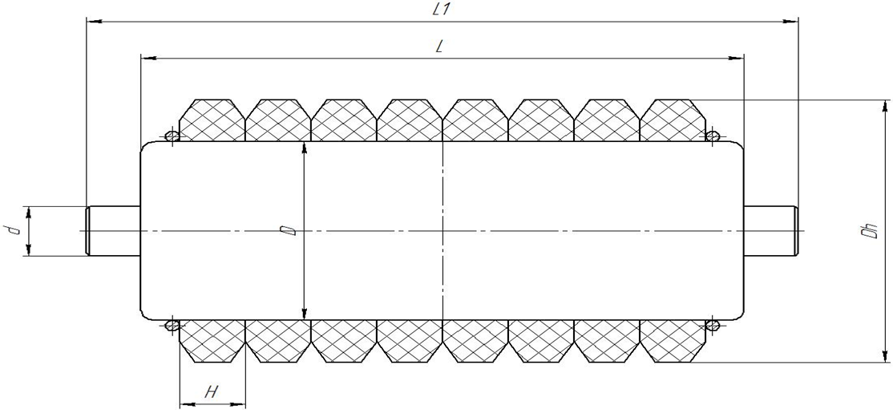

|  |  |  |  |  |  |  |  |  |  |  |  |  |  |
| --- | --- | --- | --- | --- | --- | --- | --- | --- | --- | --- | --- | --- | --- |
| **№** | **L** | **L1** | **D** | **d** | **d1** | **l** | **l1** | **l2** | **b** | **Dh** | **H** | **Подшипник** | **Кол-во** |
|  |  |  |  |  |  |  |  |  |  |  |  |  |  |
|  |  |  |  |  |  |  |  |  |  |  |  |  |  |
|  |  |  |  |  |  |  |  |  |  |  |  |  |  |
|  |  |  |  |  |  |  |  |  |  |  |  |  |  |



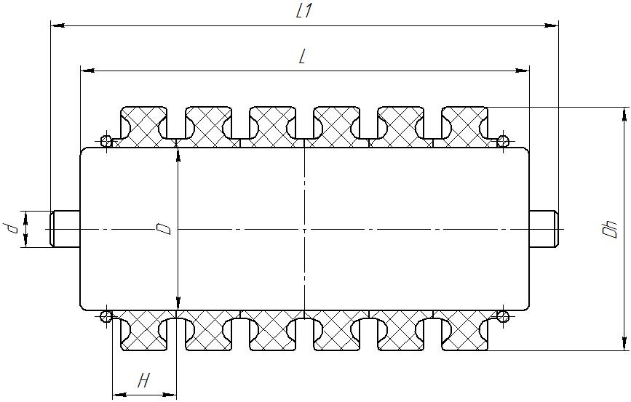**Опросный лист для заказа амортизирующих роликов ВИД 3**



|  |  |  |  |  |  |  |  |  |  |  |  |  |  |
| --- | --- | --- | --- | --- | --- | --- | --- | --- | --- | --- | --- | --- | --- |
| **№** | **L** | **L1** | **D** | **d** | **d1** | **l** | **l1** | **l2** | **b** | **Dh** | **H** | **Подшипник** | **Кол-во** |
|  |  |  |  |  |  |  |  |  |  |  |  |  |  |
|  |  |  |  |  |  |  |  |  |  |  |  |  |  |
|  |  |  |  |  |  |  |  |  |  |  |  |  |  |
|  |  |  |  |  |  |  |  |  |  |  |  |  |  |

**Опросный лист для заказа амортизирующих роликов ВИД 4**

|  |  |  |  |  |  |  |  |  |  |  |  |  |  |
| --- | --- | --- | --- | --- | --- | --- | --- | --- | --- | --- | --- | --- | --- |
| **№** | **L** | **L1** | **D** | **d** | **d1** | **l** | **l1** | **l2** | **b** | **Dh** | **H** | **Подшипник** | **Кол-во** |
|  |  |  |  |  |  |  |  |  |  |  |  |  |  |
|  |  |  |  |  |  |  |  |  |  |  |  |  |  |
|  |  |  |  |  |  |  |  |  |  |  |  |  |  |
|  |  |  |  |  |  |  |  |  |  |  |  |  |  |

